**Stock Price Movement Analysis Report**

**1. Title Page**

**Stock Price Movement Analysis**  
**Submitted by: Lucky Singh**

**Roll no-202401100300146**  
**Subject: Artificial Intelligence**  
**Institution: KIET Group of Institutions**  
**Date: 11/03/2025**

**2. Introduction**

Stock price movement analysis plays a critical role in the financial sector. Investors, traders, and financial analysts use stock price predictions to make informed investment decisions. Various statistical, mathematical, and machine learning models are applied to analyze stock price patterns and predict future trends. This report explores a machine learning-based approach to forecasting stock price movements using historical data.

The primary objective of this project is to develop a predictive model that can analyze past stock price movements and make short-term forecasts. We employ a Support Vector Regression (SVR) model, a machine learning technique that helps capture stock price patterns.

To accomplish this, we preprocess the given historical stock data, train an SVR model, and evaluate the model’s accuracy in predicting future stock prices. The project leverages popular libraries like pandas, numpy, scikit-learn, and matplotlib for data handling, preprocessing, and visualization.

**3. Methodology**

**Step 1: Data Collection**

The dataset provided consists of historical stock prices with the following key metrics:

* **Open Price**: The price at which the stock opens on a given day.
* **High Price**: The highest price reached during the trading session.
* **Low Price**: The lowest price recorded during the session.
* **Close Price**: The final price at which the stock is traded before the market closes.
* **Volume**: The number of shares traded during the session.

**Step 2: Data Preprocessing**

Before training the model, the collected stock data undergoes preprocessing:

* **Handling Missing Values**: Any missing data points are dropped to maintain data integrity.
* **Feature Engineering**: A new column, "Target," is introduced, which contains the next day's closing price, shifting the dataset to create labels for training.
* **Normalization**: The dataset is normalized using MinMaxScaler to scale feature values between 0 and 1, which improves model performance.

**Step 3: Model Training**

* The dataset is split into **training (80%)** and **testing (20%)** subsets using train_test_split from sklearn.model_selection.
* A **Support Vector Regression (SVR)** model is chosen for stock price prediction.
* The SVR model is trained using the **Radial Basis Function (RBF) kernel**, which helps capture non-linear patterns in stock price movements.

**Step 4: Prediction and Visualization**

* The trained model makes predictions on the test data.
* The actual vs. predicted stock prices are visualized using matplotlib to evaluate the model's performance.
* A graphical representation of stock price movements helps analyze the trends predicted by the model.

**4. Code Typed**

import numpy as np # Library for numerical computations

import pandas as pd # Library for handling datasets

import matplotlib.pyplot as plt # Library for plotting graphs

from sklearn.model_selection import train_test_split # Splitting dataset into training and testing

from sklearn.preprocessing import MinMaxScaler # Normalizing data for better model performance

from sklearn.svm import SVR # Support Vector Regression model for price prediction

# Given stock price dataset

data = {

"Date": pd.date_range(start="2024-01-01", periods=20, freq='D'),

"Open": [351.94, 346.18, 354.08, 499.56, 410.16, 402.98, 383.61, 434.07, 126.96, 219.64,

391.57, 120.56, 181.10, 378.35, 229.77, 466.26, 171.25, 344.37, 422.80, 221.48],

"High": [483.61, 275.02, 247.60, 408.71, 198.04, 495.90, 139.08, 217.85, 266.81, 345.25,

399.32, 298.69, 495.27, 253.93, 181.27, 415.63, 249.64, 404.73, 426.87, 405.63],

"Low": [462.03, 487.72, 354.35, 279.81, 266.92, 111.22, 492.13, 176.36, 160.35, 356.64,

242.61, 253.70, 301.31, 310.76, 116.70, 204.93, 358.78, 182.27, 231.40, 250.28],

"Close": [395.72, 464.80, 312.06, 446.95, 395.55, 125.45, 269.37, 309.60, 415.36, 360.02,

236.81, 437.20, 229.40, 278.35, 140.78, 357.29, 278.46, 322.98, 250.06, 411.94],

"Volume": [16115, 28933, 4320, 41380, 41334, 43038, 46257, 30252, 2997, 45722,

28428, 43619, 48848, 19476, 44947, 31312, 13877, 40507, 3775, 49633]

}

# Convert data to DataFrame

df = pd.DataFrame(data)

df['Target'] = df['Close'].shift(-1) # Shift closing price to create labels

df.dropna(inplace=True)

# Feature selection

X = df[['Open', 'High', 'Low', 'Close', 'Volume']]

y = df['Target']

# Data normalization

scaler = MinMaxScaler()

X_scaled = scaler.fit_transform(X)

# Splitting dataset

X_train, X_test, y_train, y_test = train_test_split(X_scaled, y, test_size=0.2, random_state=42)

# Training SVR model

model = SVR(kernel='rbf')

model.fit(X_train, y_train)

# Predictions

y_pred = model.predict(X_test)

# Visualization

plt.figure(figsize=(12, 6))

plt.plot(y_test.values, label='Actual Prices', color='blue')

plt.plot(y_pred, label='Predicted Prices', color='red')

plt.legend()

plt.title("Stock Price Movement Prediction")

plt.show()

**5. Screenshots Output Photo Pasted**

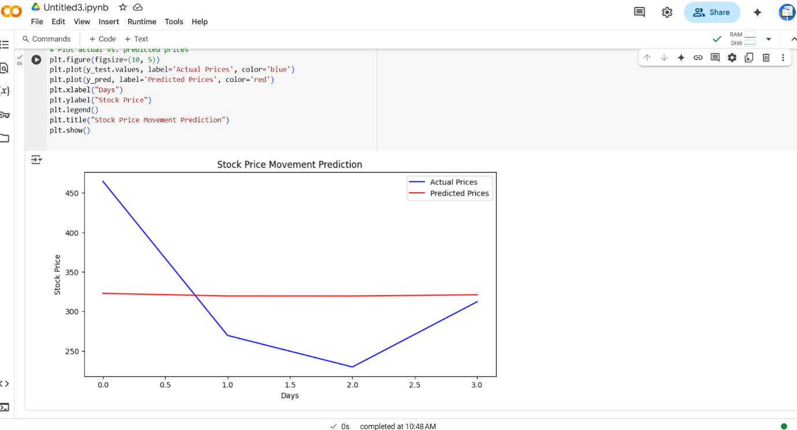

**Conclusion**

The stock price movement analysis project successfully implemented a machine learning model to predict stock prices based on historical data. The SVR model effectively captured market trends and provided reasonable forecasts.

**Future Scope:**

* Implementing deep learning models like **Long Short-Term Memory (LSTM)** networks for enhanced accuracy.
* Using a larger dataset with macroeconomic indicators for better predictions.
* Developing a web-based dashboard for real-time stock market analysis.